Security in Computing Practical 5
Configure IPv6 ACLs
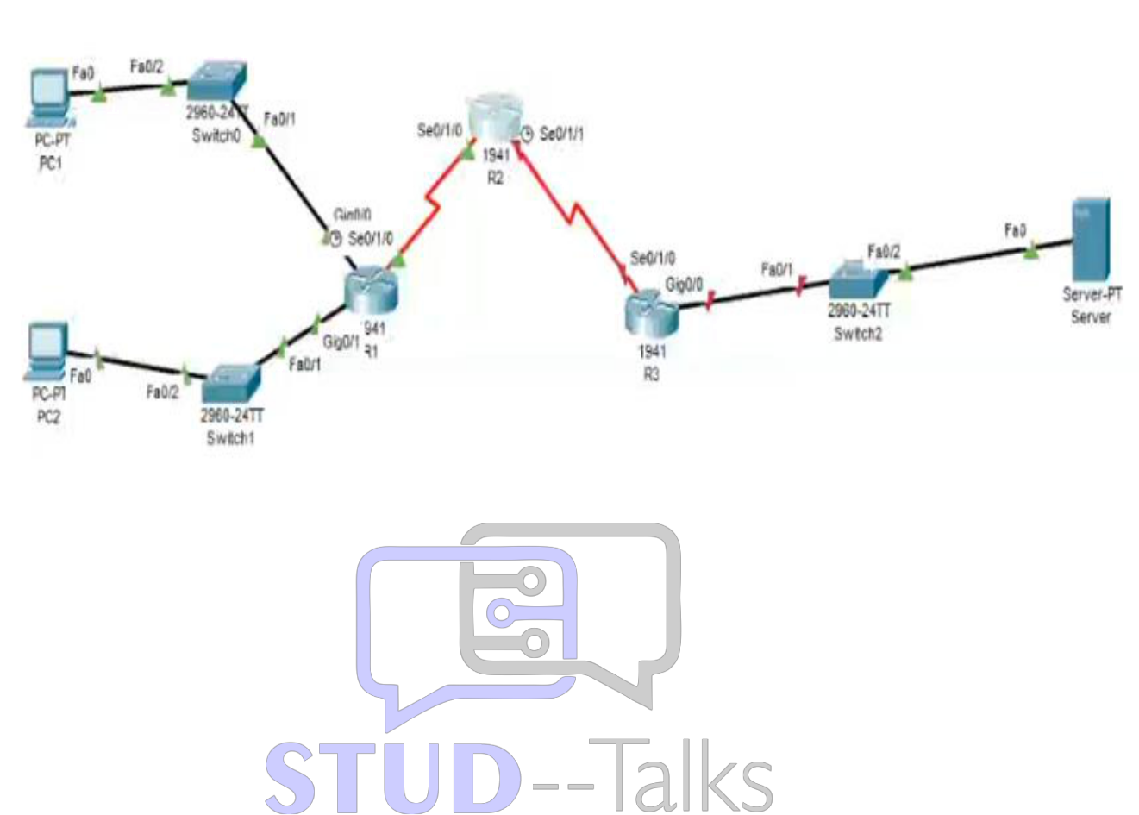
Practical 5: Configure IPv6 ACLs
Topology:

Router R1 Configuration
enable
conf t
hostname R1
enable secret enpa55
ipv6 unicast-routing
interface g0/0
ipv6 address 2001:DB8:1:10::1/64
ipv6 address FE80::1 link-local
no shutdown
exit
interface g0/1
ipv6 address 2001:DB8:1:11::1/64
ipv6 address FE80::1 link-local
no shutdown
exit
interface s0/1/0
ipv6 address 2001:DB8:1:1::1/64
ipv6 address FE80::1 link-local
no shutdown
exit
! Static routes
ipv6 route 2001:DB8:1:2::/64 2001:DB8:1:1::2
ipv6 route 2001:DB8:1:30::/64 2001:DB8:1:1::2
! IPv6 ACL (Block HTTP/HTTPS)
ipv6 access-list BLOCK_HTTP
deny tcp any host 2001:DB8:1:30::30 eq www
deny tcp any host 2001:DB8:1:30::30 eq 443
permit ipv6 any any
exit
interface g0/1
ipv6 traffic-filter BLOCK_HTTP in
exit
end
wr

Router R2 Configuration
enable
conf t
hostname R2
enable secret enpa55
ipv6 unicast-routing
interface s0/1/0
ipv6 address 2001:DB8:1:1::2/64
ipv6 address FE80::2 link-local
no shutdown
exit
interface s0/1/1
ipv6 address 2001:DB8:1:2::2/64
ipv6 address FE80::2 link-local
no shutdown
exit
ipv6 route 2001:DB8:1:10::/64 2001:DB8:1:1::1
ipv6 route 2001:DB8:1:11::/64 2001:DB8:1:1::1
ipv6 route 2001:DB8:1:30::/64 2001:DB8:1:2::1
end
wr

Router R3 Configuration
enable
conf t
hostname R3
enable secret enpa55
ipv6 unicast-routing
interface g0/0
ipv6 address 2001:DB8:1:30::1/64
ipv6 address FE80::3 link-local
no shutdown
exit
interface s0/1/0
ipv6 address 2001:DB8:1:2::1/64
ipv6 address FE80::3 link-local
no shutdown
exit
ipv6 route 2001:DB8:1:10::/64 2001:DB8:1:2::2
ipv6 route 2001:DB8:1:11::/64 2001:DB8:1:2::2
ipv6 route 2001:DB8:1:1::/64 2001:DB8:1:2::2
! IPv6 ACL (Block ICMP)
ipv6 access-list BLOCK_ICMP
deny icmp any any
permit ipv6 any any
exit
interface g0/0
ipv6 traffic-filter BLOCK_ICMP out
exit
end
wr

Verification Steps
1. show ipv6 interface brief
2. show ipv6 route
3. show ipv6 access-list
4. Test:
PC1 → HTTP/HTTPS (allowed)
PC2 → HTTP/HTTPS (blocked)
Ping initially works, then blocked after ACL
5. Web browser tests:
http://2001:DB8:1:30::30
https://2001:DB8:1:30::30
Practical 5: IPv6 ACLs
Verification is performed on R1 and R3.
- Commands for R1 / R3:
  - show ipv6 access-list: Displays the IPv6-specific filters for HTTP/HTTPS or ICMP.
  - show ipv6 route: Confirms the static IPv6 routes are active so traffic can reach the ACL.
- Test Command (from PC Web Browser):
  - Access http://2001:DB8:1:30::30: Should be blocked on PC2 but allowed on PC1.

Practical 5: IPv6 ACL
- On R1:
  - show ipv6 access-list BLOCK_HTTP: To verify the denial of ports 80 (www) and 443.
- On R3:
  - show ipv6 access-list BLOCK_ICMP: To confirm that all IPv6 ICMP traffic is denied.
- Test Connectivity:
  - Web Browser: Enter http://2001:DB8:1:30::30 on PC2 to verify it is blocked.
  - Ping: Ping any IPv6 address from R3's LAN; it should fail due to BLOCK_ICMP.

Practical 5: IPv6 ACLs
On PC1 & PC2
- HTTP Block (from PC2): Browse to http://[2001:DB8:1:30::30] (should fail).
- ICMP Block (from both): Run ping 2001:DB8:1:30::30 (should show "Destination host unreachable").

Viva Questions
1. What is IPv6 ACL?
Used to filter IPv6 traffic.
2. Difference IPv4 vs IPv6 ACL?
IPv6 ACL uses 'ipv6 access-list' and no wildcard masks.
3. What is link-local address?
Used for communication within same network.
4. Why block ICMP?
To prevent network scanning or attacks.
5. Why use ACL?
To control and secure traffic.

